**Front-End UI/UX Mini Project**

* **Project Title:** *Responsive Portfolio Website Detailing a Restaurant Landing Page.*
* **Submitted By**: 
  + *2462311 Aksa Mariya Basil* [aksa.mariyabasil@btech.christuniversity.in](mailto:aksa.mariyabasil@btech.christuniversity.in)
  + *2462360 Sanjana Sudhir Ullal*

[sanjana.sudhir@btech.christuniversity.in](mailto:sanjana.sudhir@btech.christuniversity.in)

* + *2462332* *Joel Anthony Dsilva*

[*joel.anthony@btech.christuniversity.in*](mailto:joel.anthony@btech.christuniversity.in)

* **Course**:  *UI/UX Design Fundamentals*
* **Instructor Name**: Ms. Nagaveena
* **Institution**:  *Christ University*
* **Date of Submission**: *13/08/2025*
* **Published Output**: [*https://sanjanasudhir.github.io/Restaurant_Landing_Page/*](https://sanjanasudhir.github.io/Restaurant_Landing_Page/)

**2. Abstract**

This project presents a responsive web-based landing page for a fictional fine-dining restaurant. Developed using HTML and CSS, the website offers users a visually engaging experience, highlighting signature dishes, a curated food gallery, and key restaurant features. The navigation page serves as a central hub guiding users through:

* **Home** – Welcoming introduction and visual branding.
* **Menu** – Showcasing popular dishes like bruschetta, pizza, and desserts.
* **Contact** – Location and reservation info.

This project demonstrates effective layout, visual design, and basic interactivity without JavaScript.

**3. Objectives**

* Design a user-friendly interface using modern UI principles
* Develop a fully responsive layout using only HTML and CSS
* Implement structured HTML5 semantic elements
* Apply CSS styling for branding, layout, and responsive behavior
* Ensure accessibility and readability across devices

**4. Scope of the Project**

* Focused on front-end design only
* No JavaScript or server-side integration
* Intended for desktop, tablet, and mobile viewports
* Used only open-source tools and pure code (no libraries)

**5. Tools & Technologies Used**

| Tool/Technology | Purpose |
| --- | --- |
| HTML5 | Markup and content structure |
| CSS3 | Styling and layout management |
| VS Code | Code editor |
| Chrome DevTools | Testing and debugging |

**6. HTML Structure Overview**

* Used semantic tags: <header>, <nav>, <main>, <section>, <footer>
* Structured into reusable sections: About, Projects, Contact
* Navigation menu using <ul> and anchor links for smooth scrolling

**7. CSS Styling Strategy**

* Used external CSS file (style.css)
* Organized with comments and sections
* Techniques used:
  + Flexbox and Grid for layout
  + Media Queries for responsiveness
  + CSS Variables for theme customization
  + Hover effects and transitions
  + Mobile-first design approach

**8. Key Features**

| Feature | Description |
| --- | --- |
| Responsive Design | Adapts seamlessly to all screen sizes |
| Smooth Navigation | Fixed top nav with anchor links |
| Project Cards | Flex-based layout with hover effects |
| Contact Form (non-functional) | Placeholder layout for inputs and button |
| Accessible Fonts & Colors | High contrast and readable typography |

**9. Challenges Faced & Solutions**

| Challenge | Solution |
| --- | --- |
| Overlapping elements on small screens | Used media queries to stack elements |
| Difficulty aligning items using float | Shifted to Flexbox and Grid |
| Typography scaling issue | Used relative units (em/rem) instead of px |

**10. Outcome**

* Achieved a clean, consistent, and visually engaging front-end layout
* All key components function as intended using just HTML and CSS
* Learned about layout responsiveness and UI hierarchy in depth

**11. Future Enhancements**

* Add JavaScript for interactivity (form validation, dynamic content)
* Integrate animations or transitions
* Backend integration for form submission
* Theme toggler (light/dark mode)

**12. Sample Code**

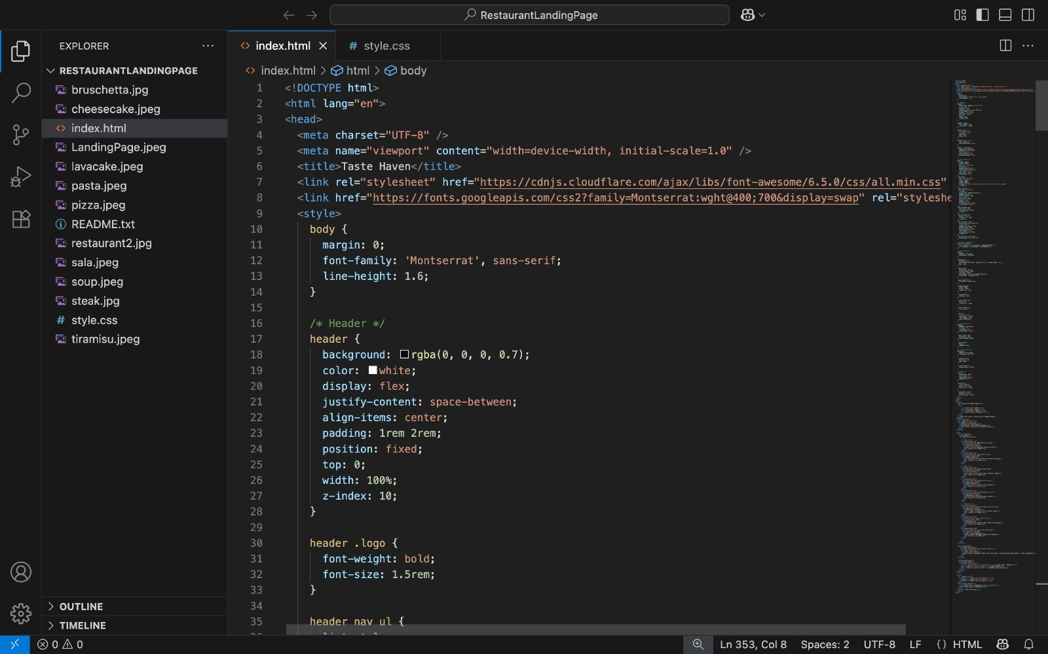

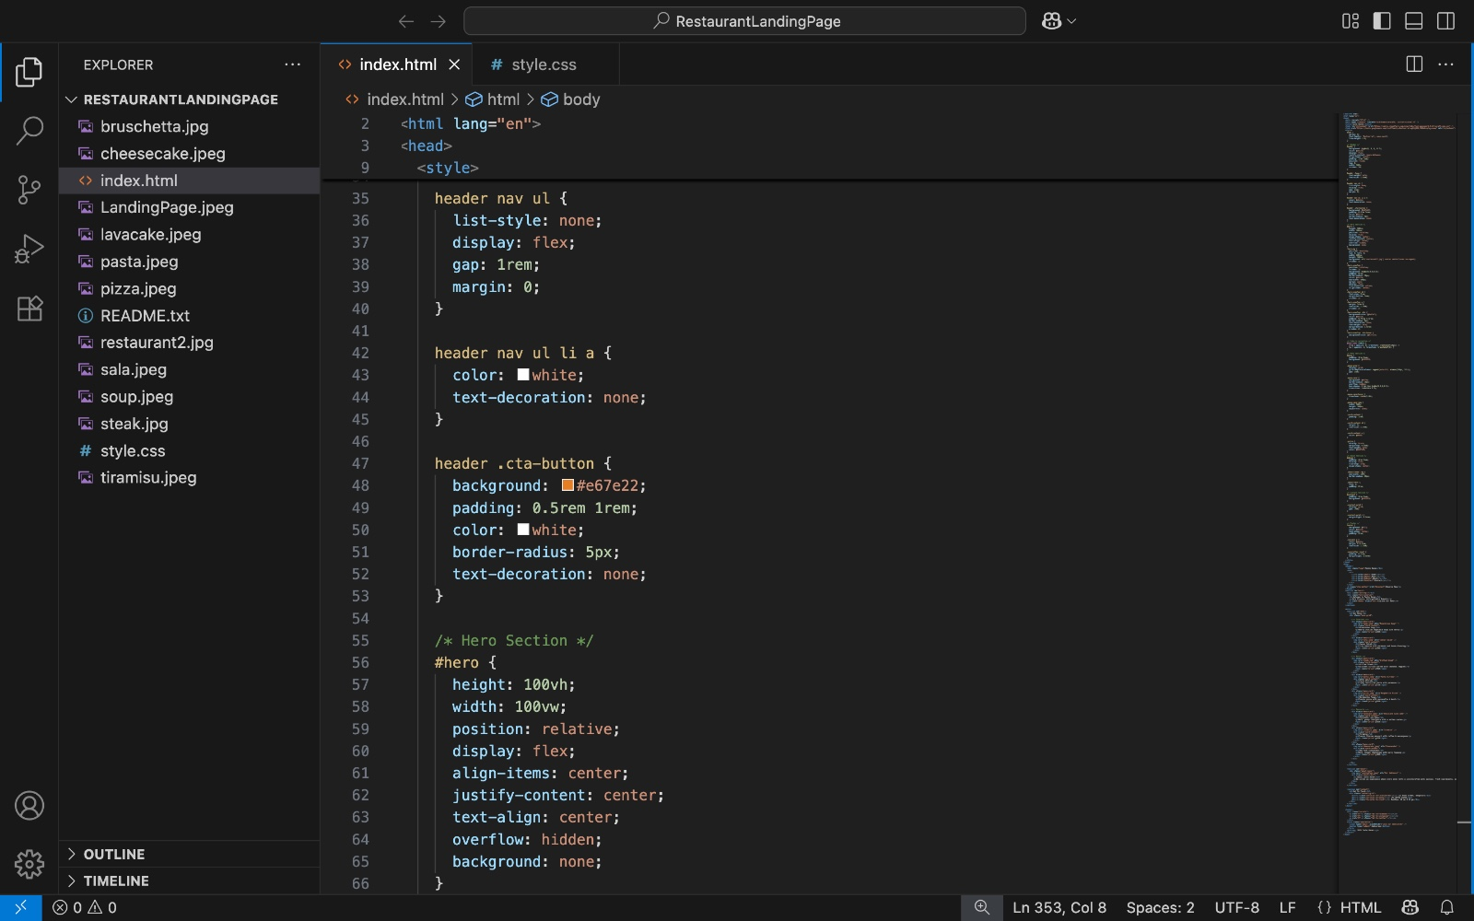

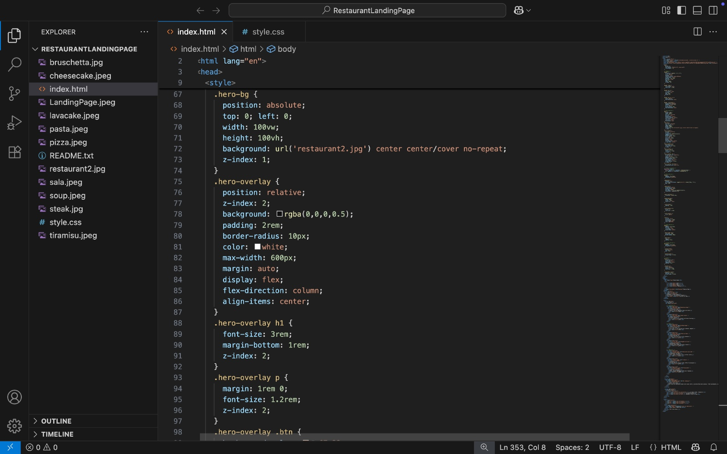

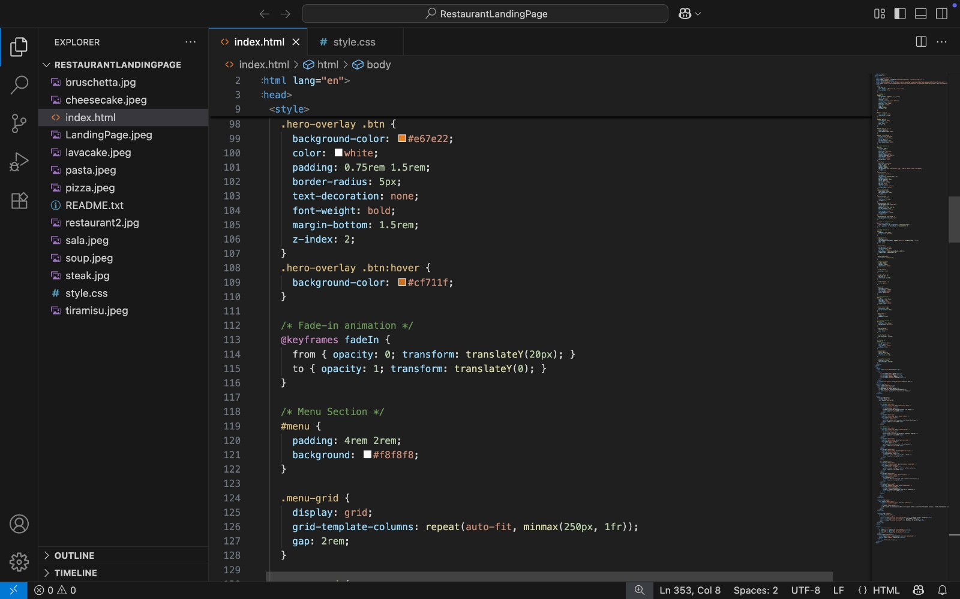

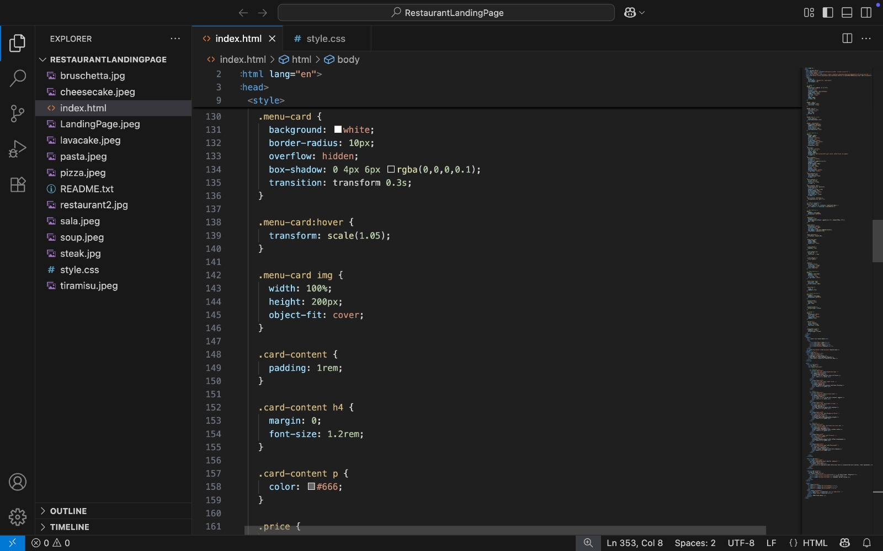

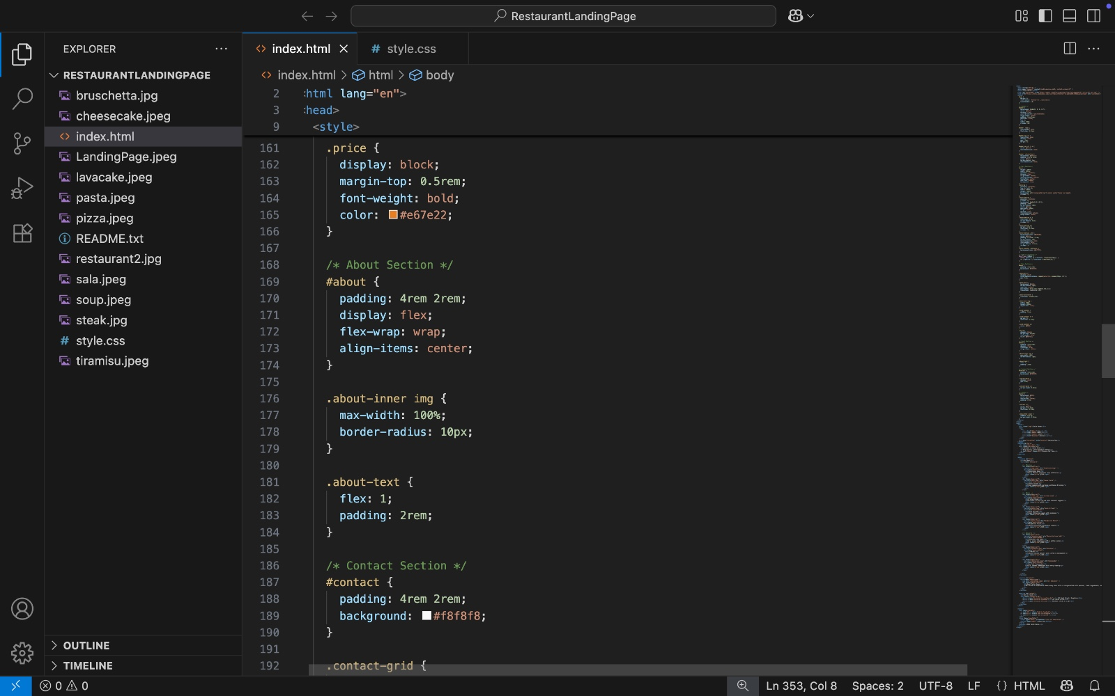

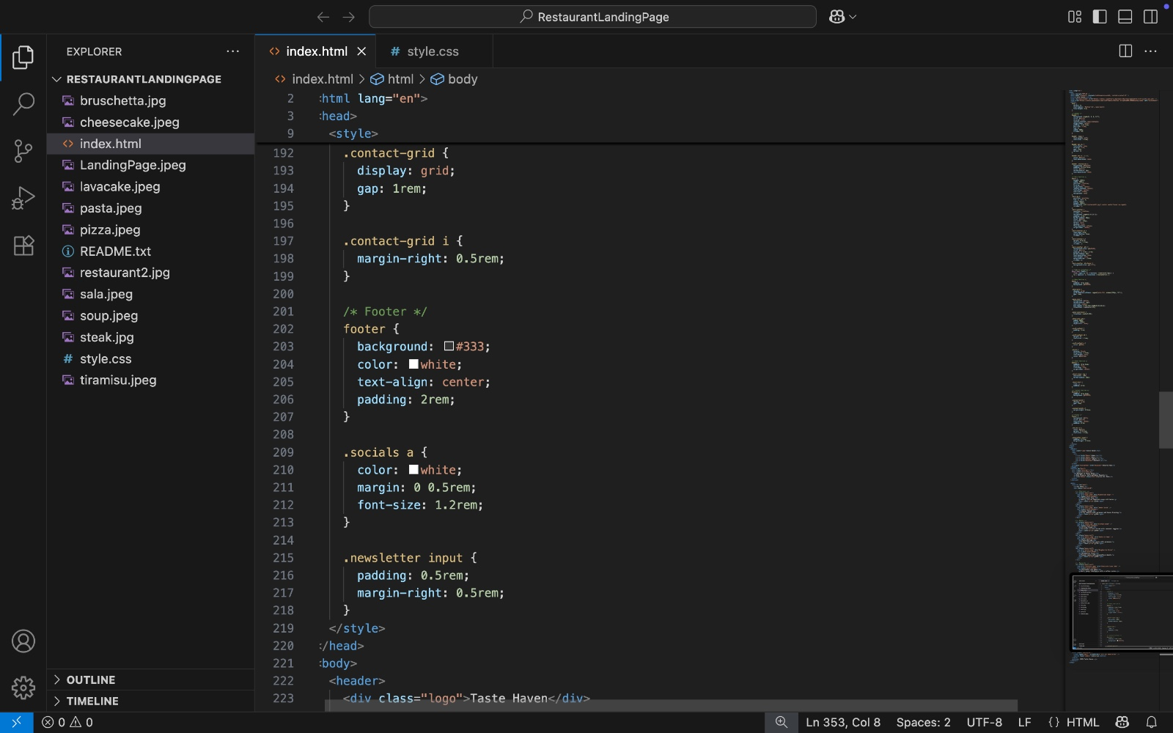

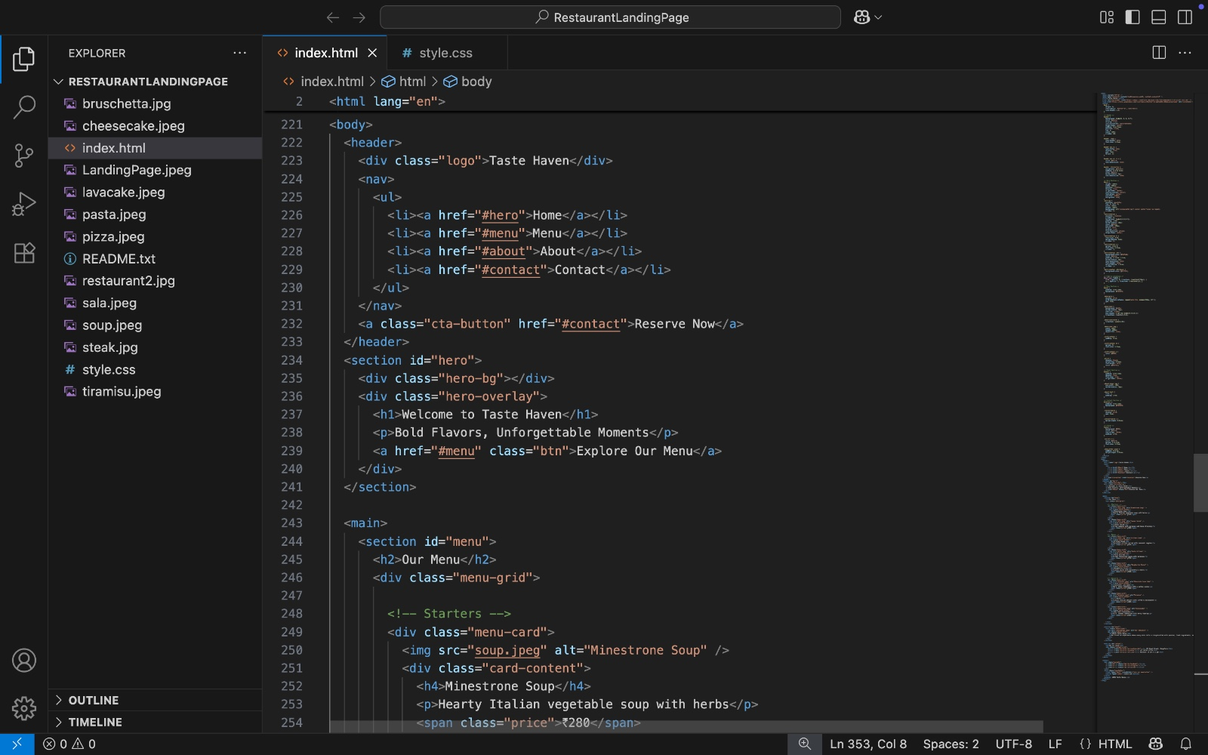

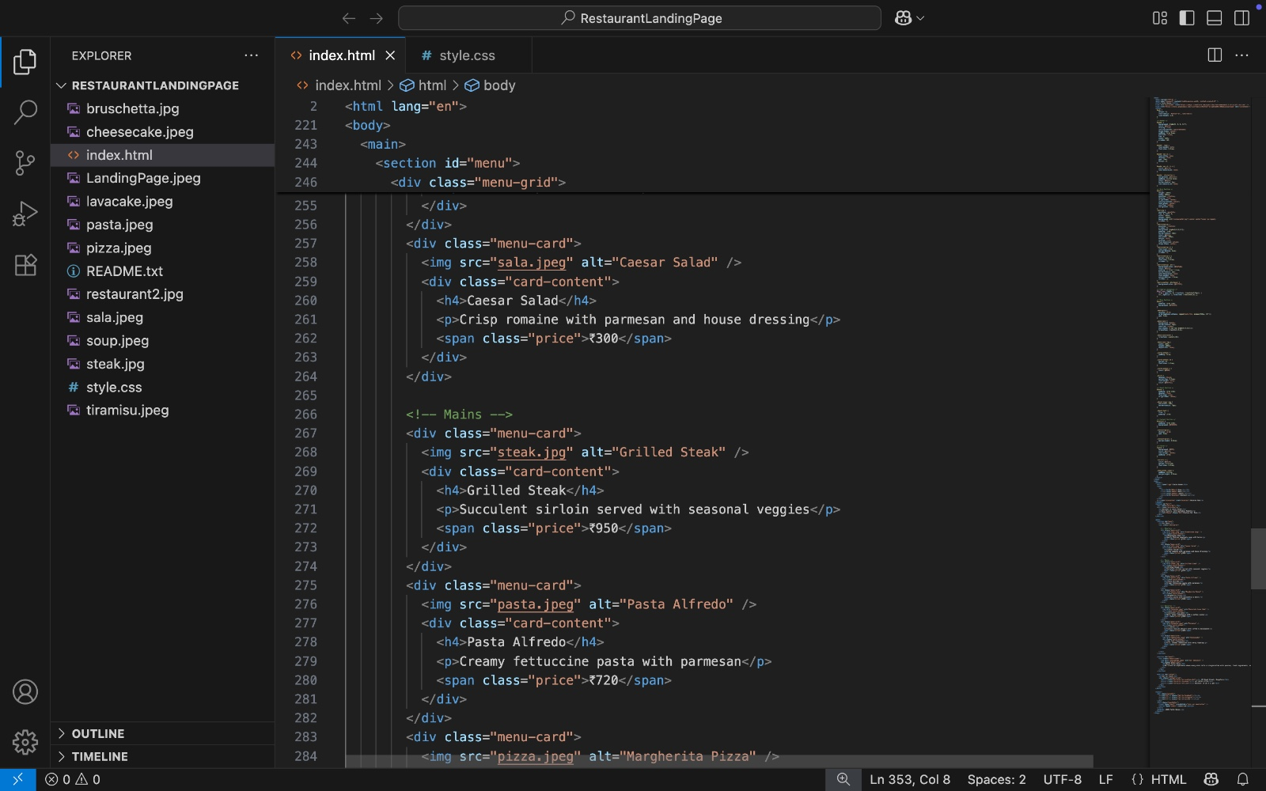

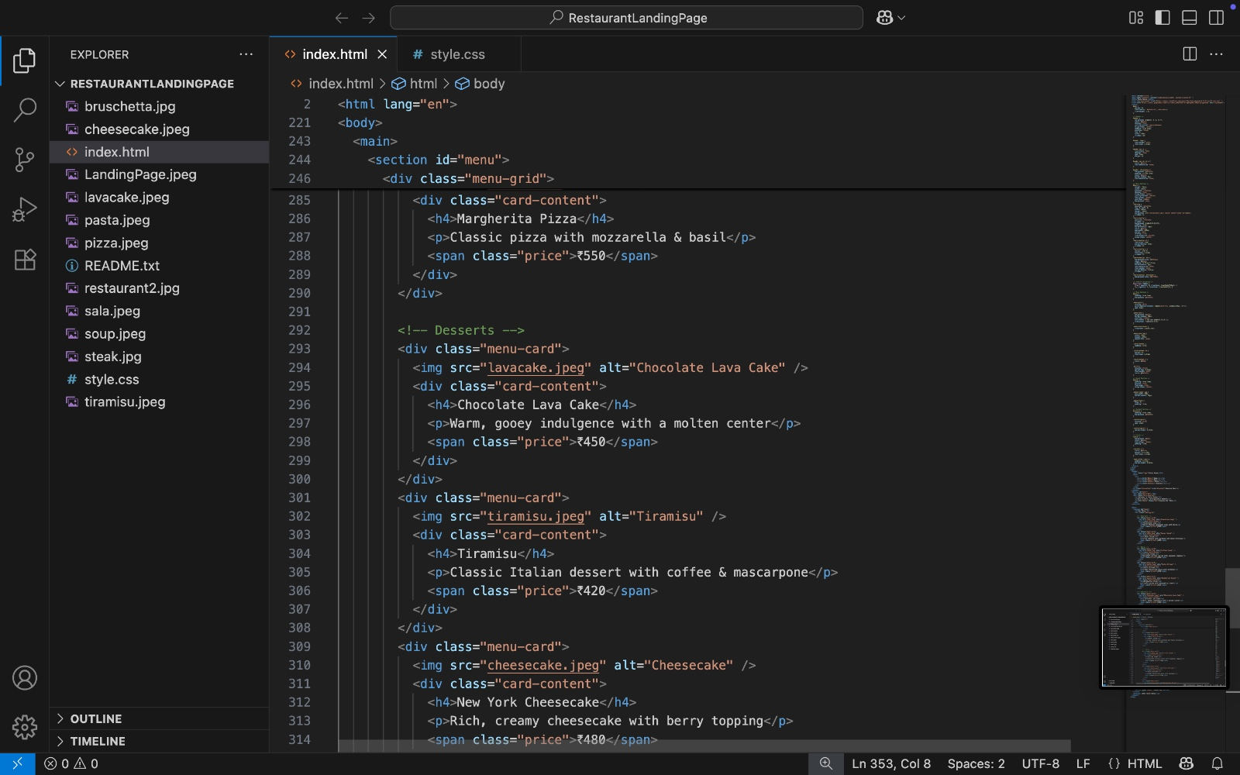

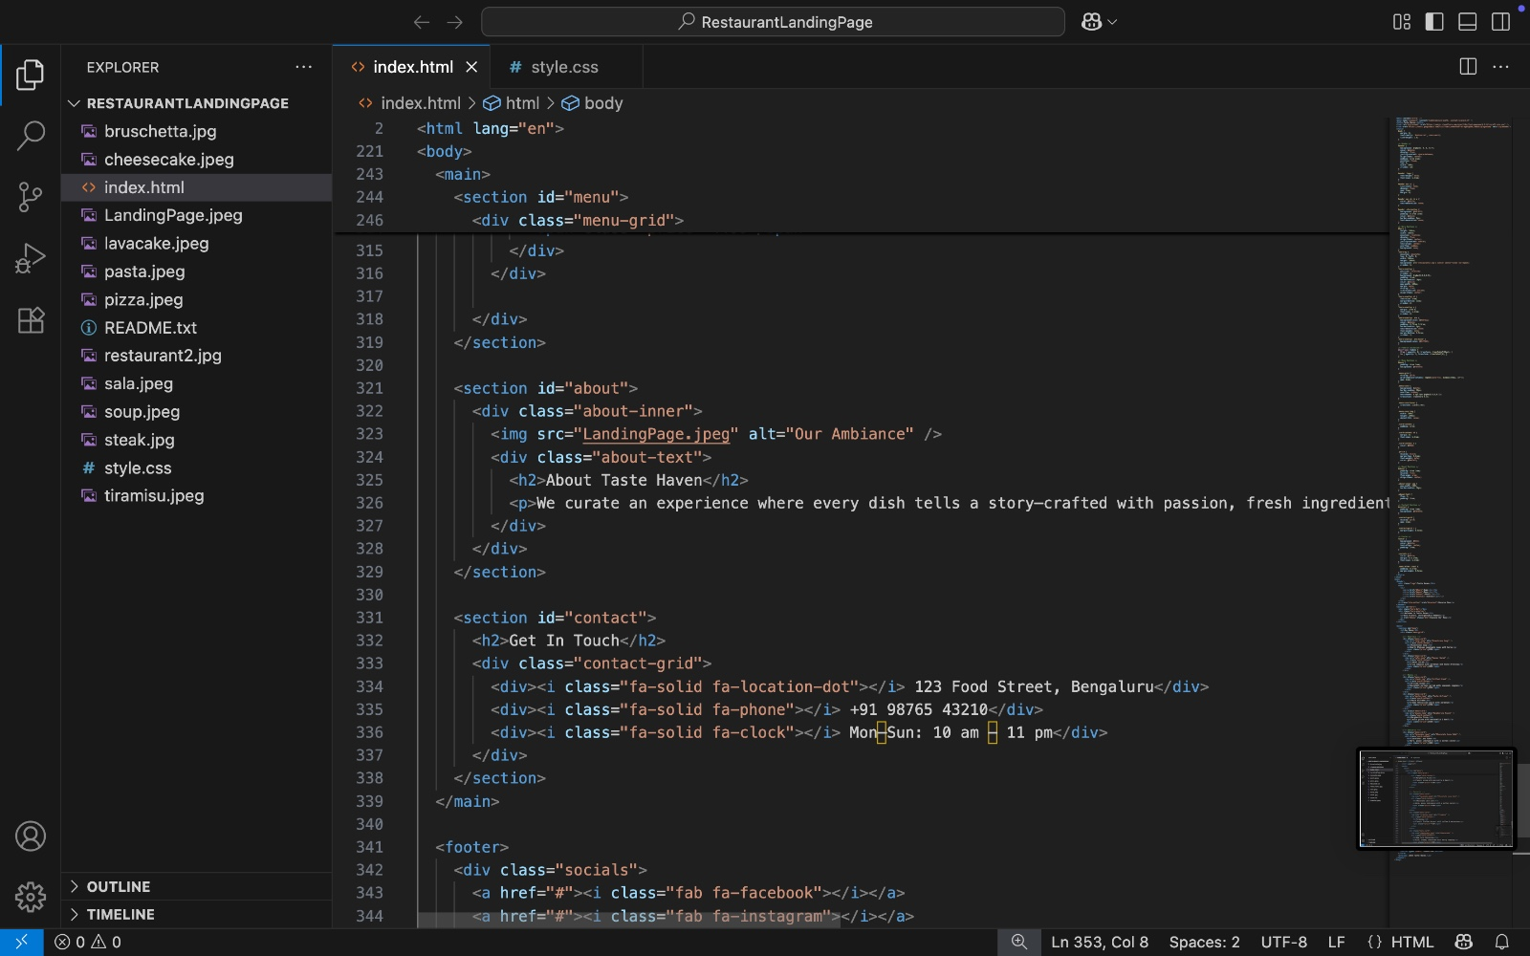

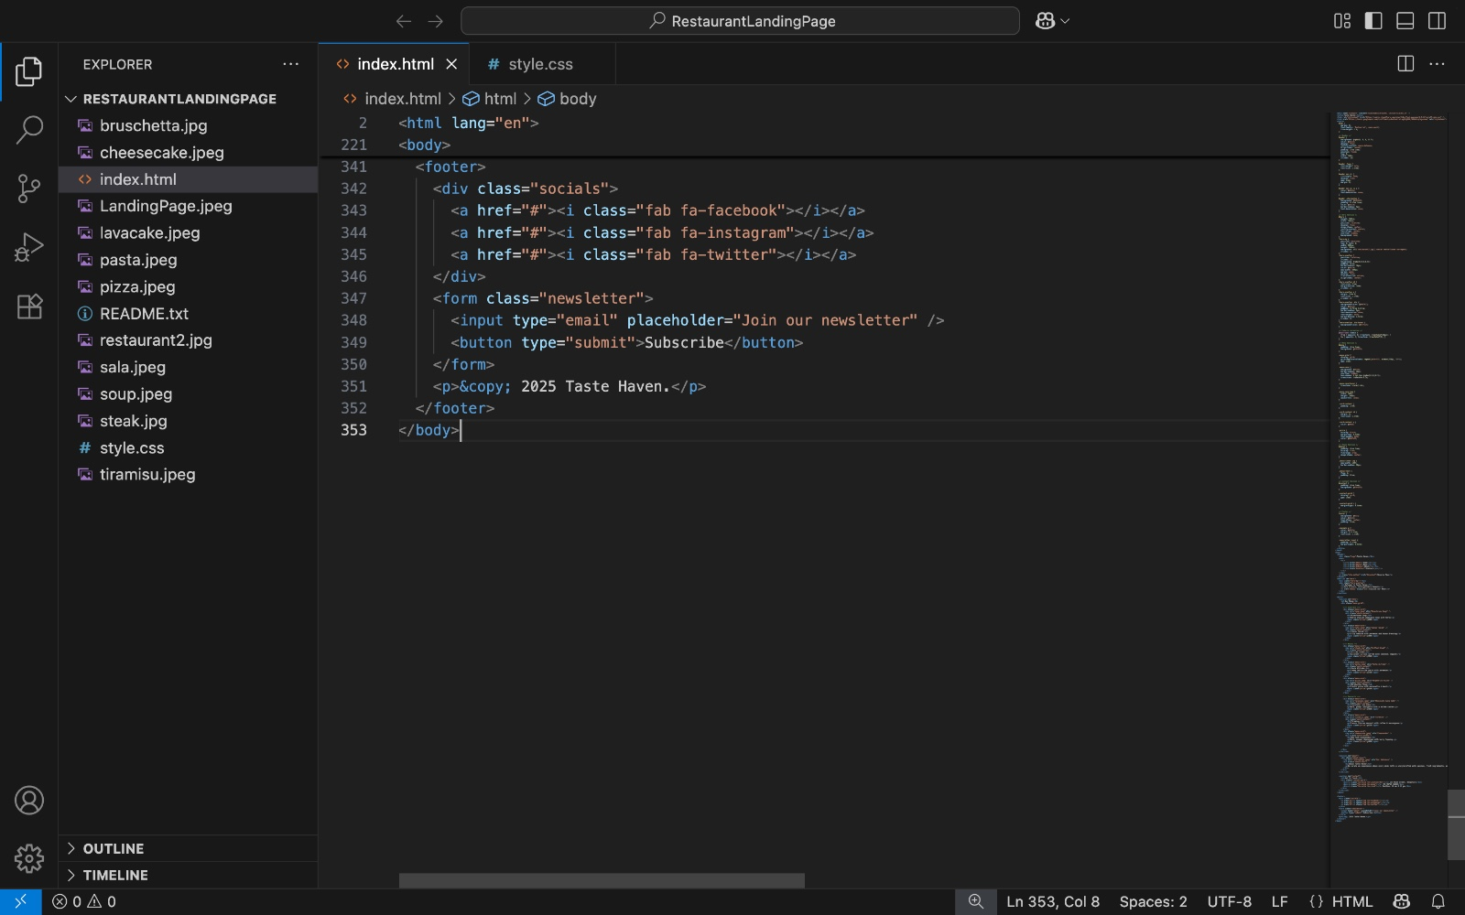

**13. Screenshots of Final Output**

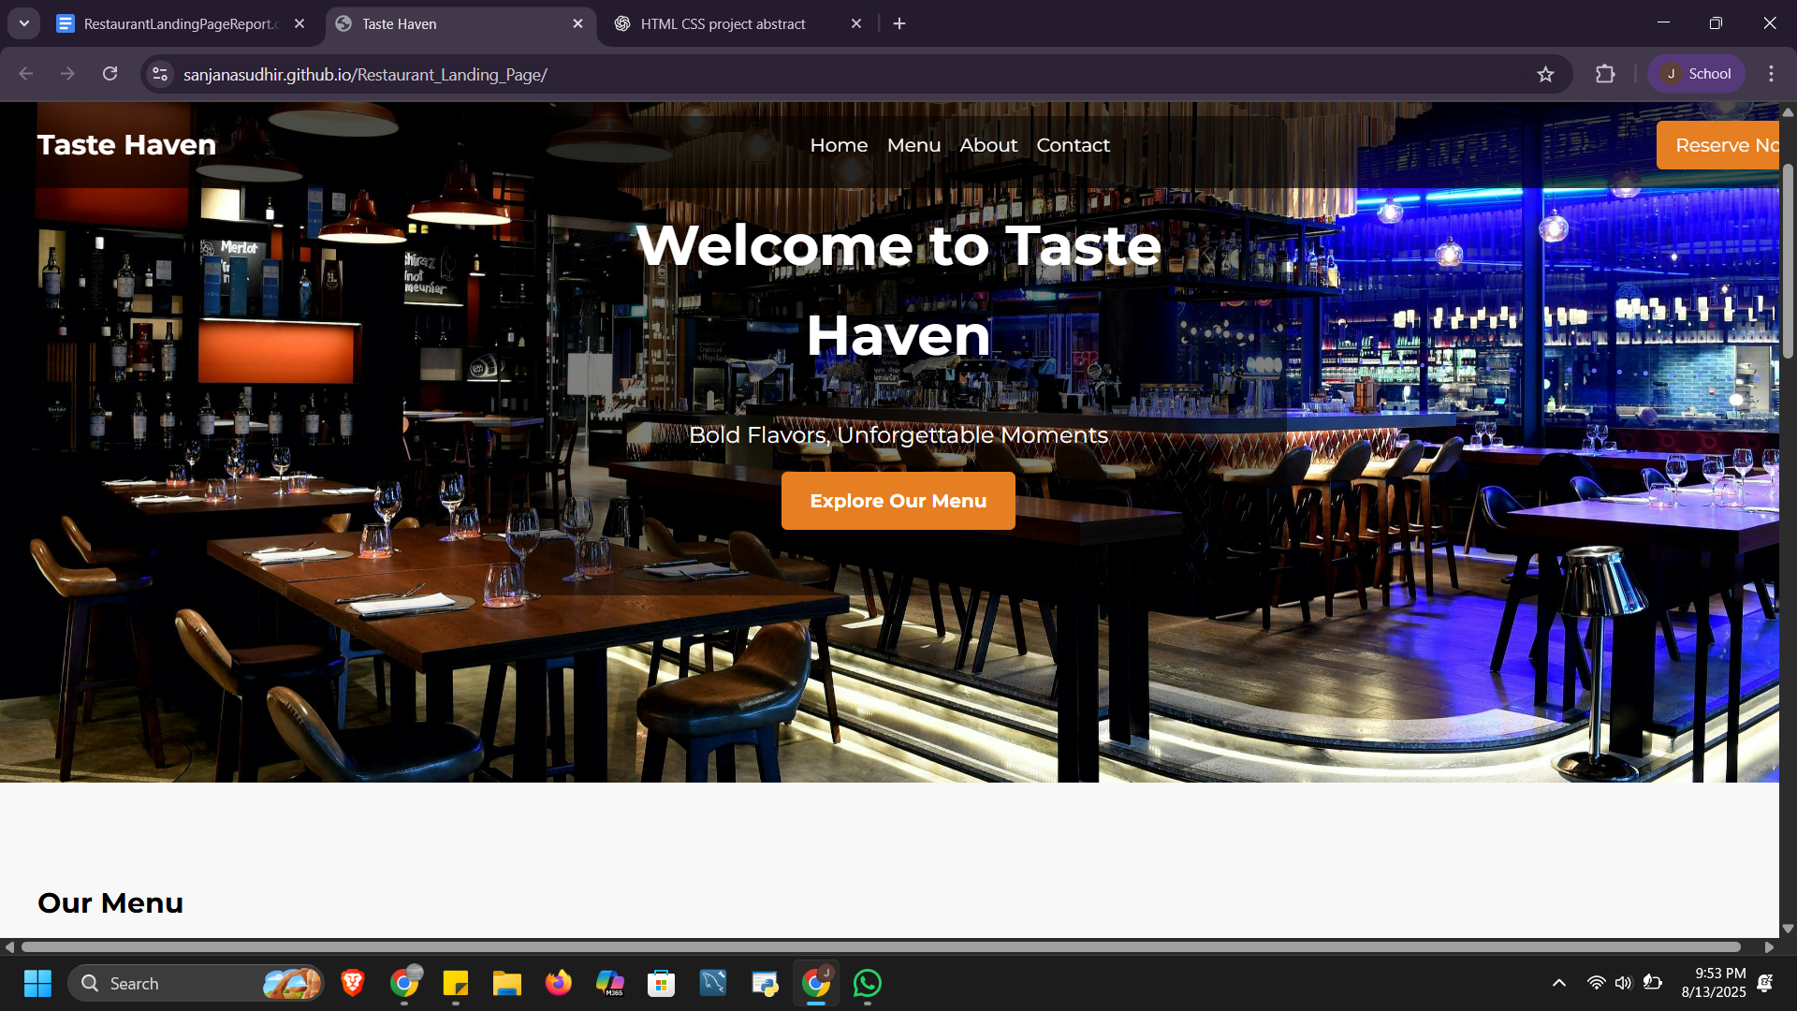

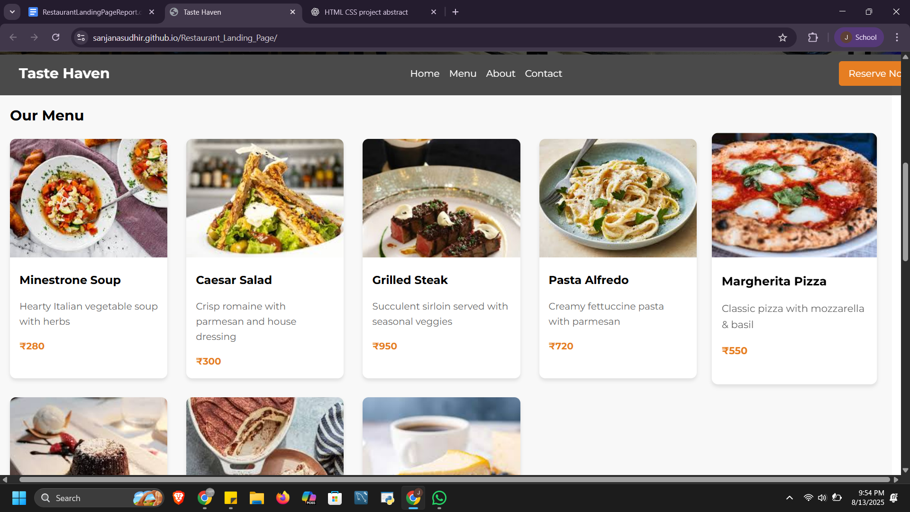

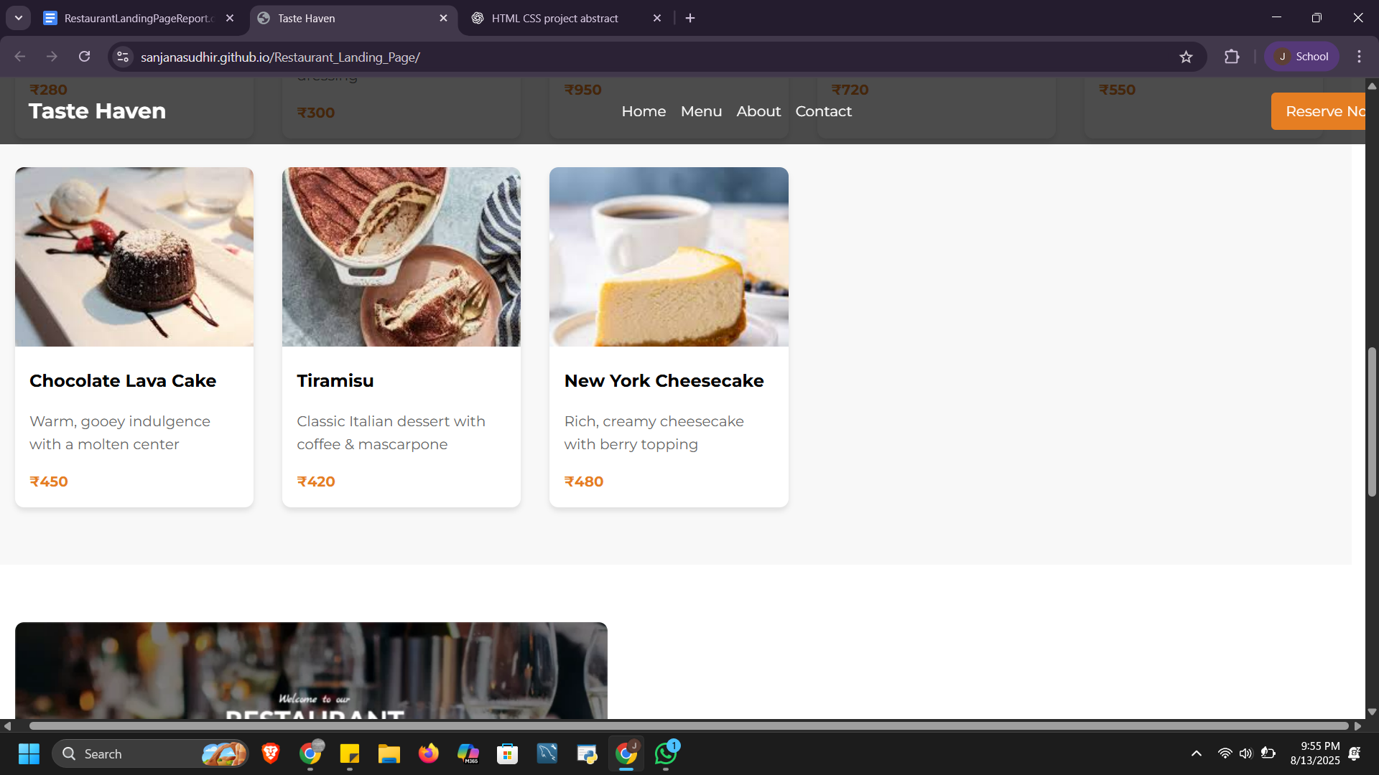

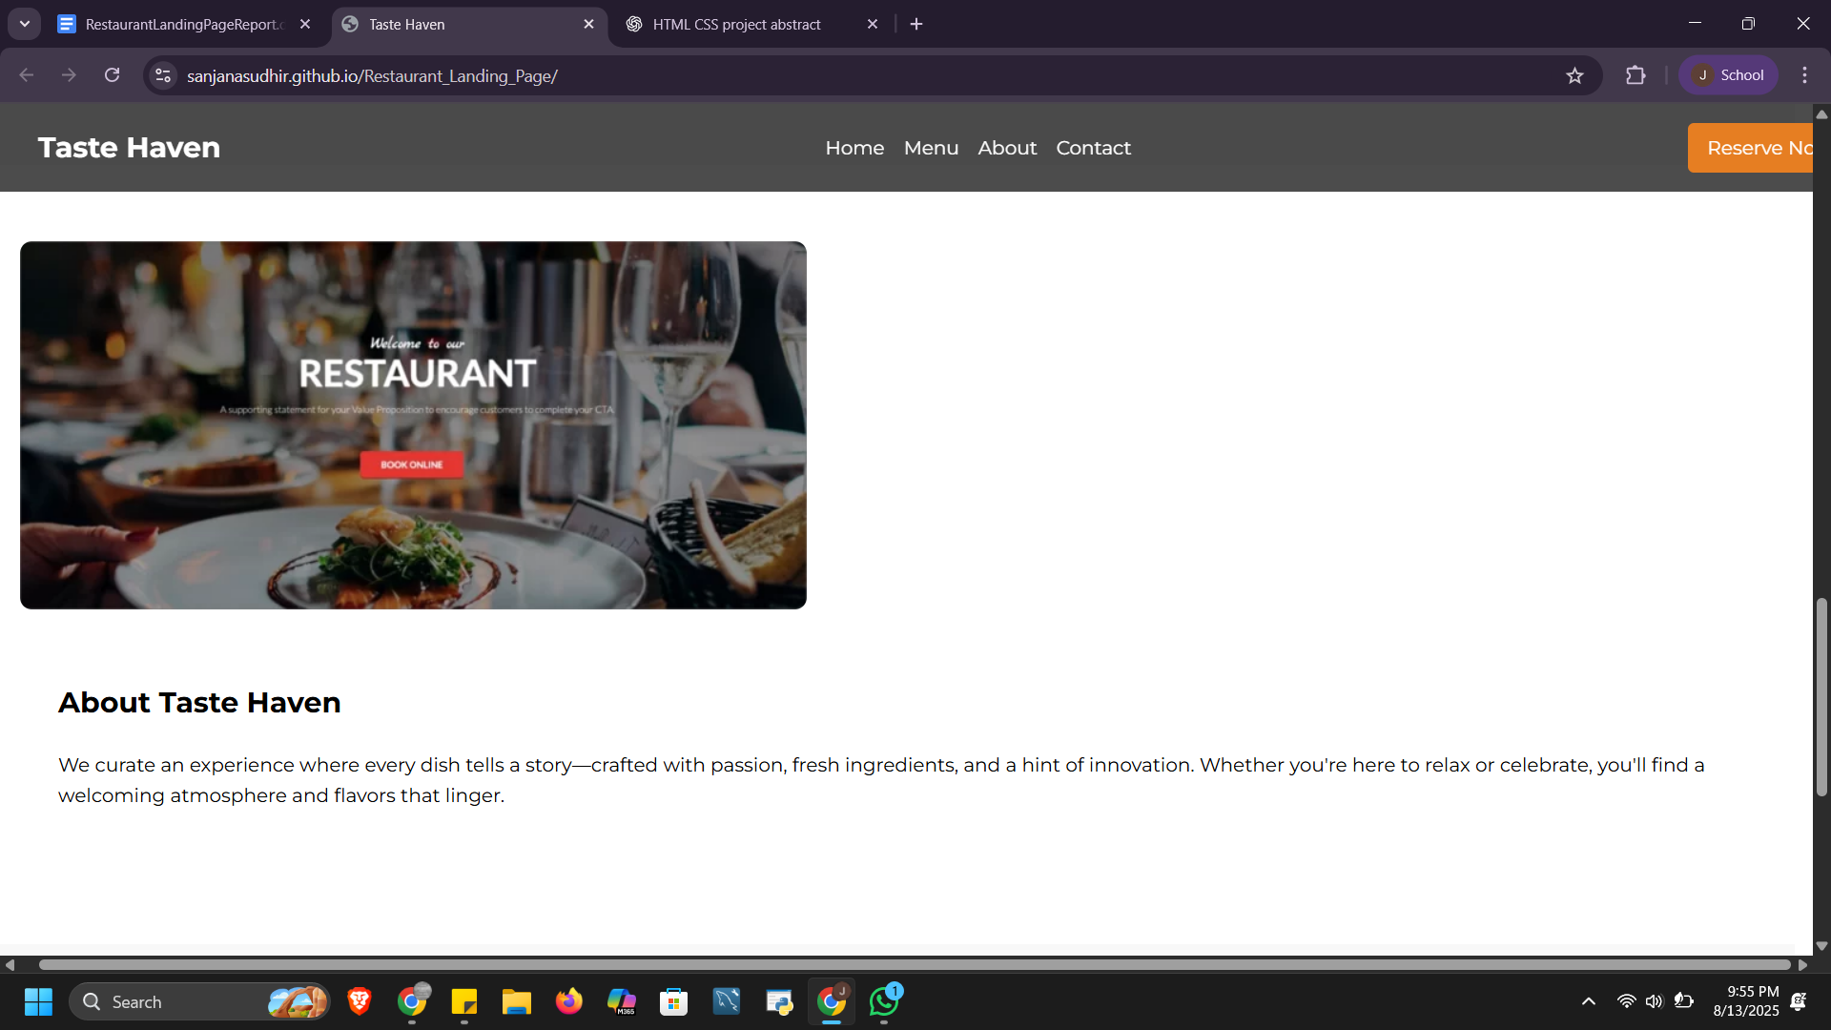

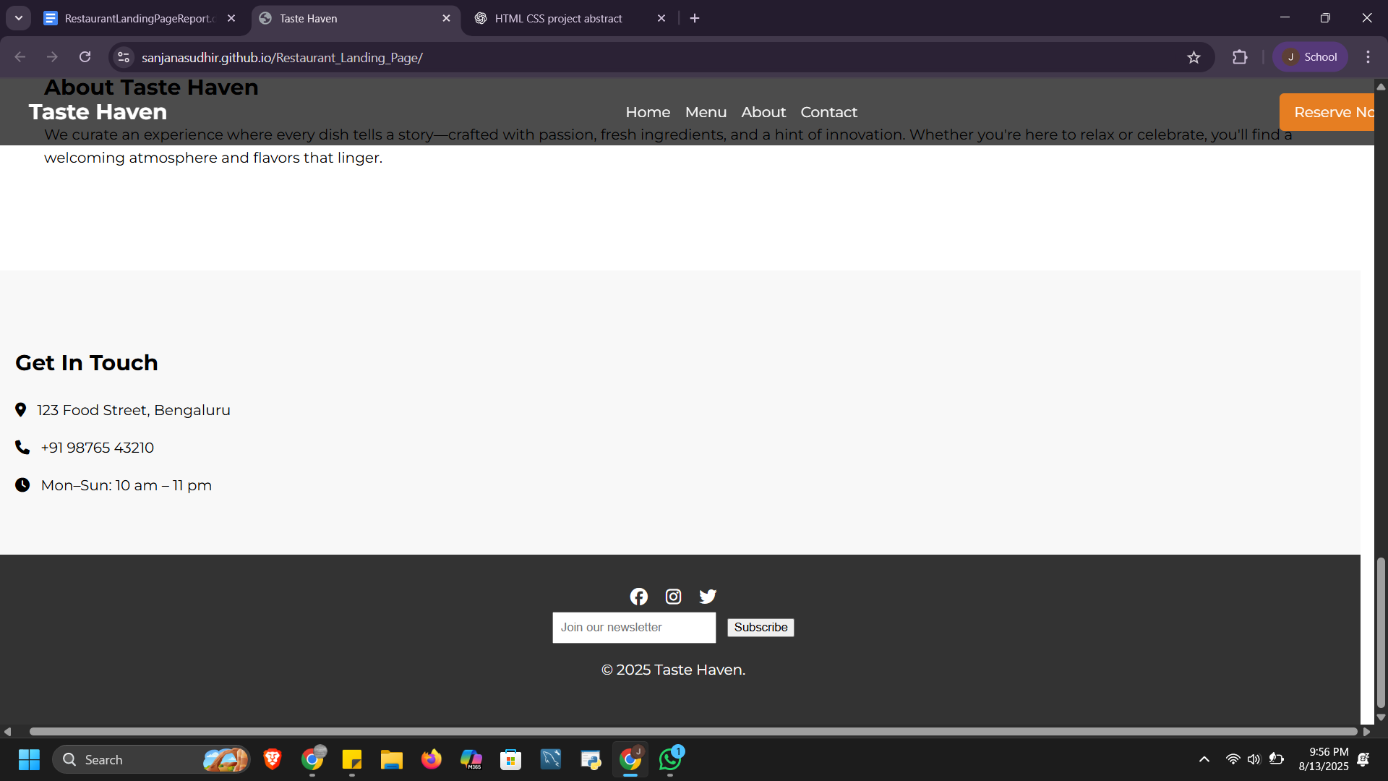

**11. Conclusion**

This is a personal portfolio website showcases the user's skills, projects, resume, and contact form. This mini project helped us strengthen our front-end development skills using only HTML and CSS. We gained practical insights into responsive design, layout structuring, and user interface aesthetics. The hands-on implementation of design principles also enhanced our understanding of user-centric web design.

**12. References**

* L&T LMS : https://learn.lntedutech.com/Landing/MyCourse